1.Create user with name Techie and provide sudo access to user.
Step 1: Create the User
sudo adduser Techie
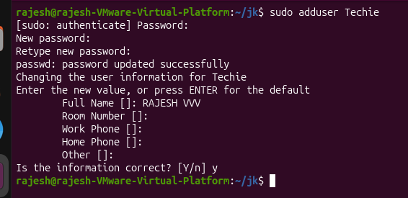
Step 2: Verify the User
id Techie
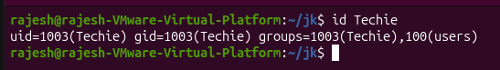
Step 3: Provide Sudo Access
sudo usermod -aG sudo Techie
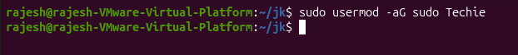
Step 4: Verify Sudo Access
groups Techie
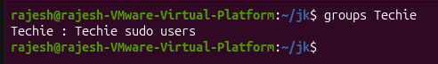
Step 5: Switch to the User
su - Techie
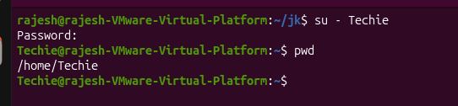
Step 6: Test Sudo Privileges
sudo apt update
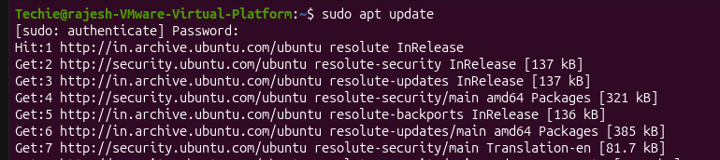
2.Navigate to the home directory.
Using cd
cd
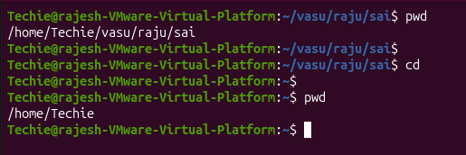
3.Create a new directory.
mkdir rajesh33
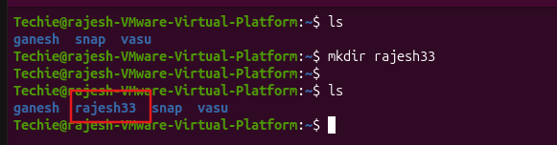
4.List the contents of a directory.
ls
ll
ls -a
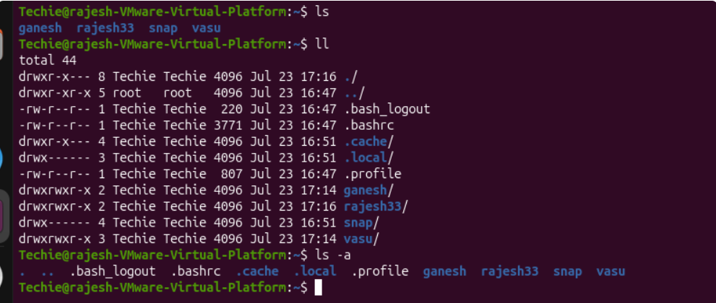
5.Change the current directory.
cd dir_name
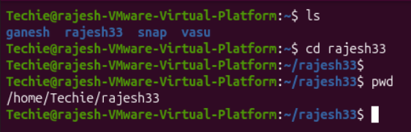
6.Create a new empty file.
touch <file-name>
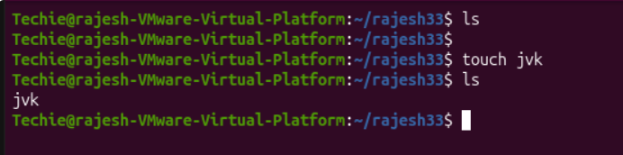
7.View the contents of a file.
cat <file_name>
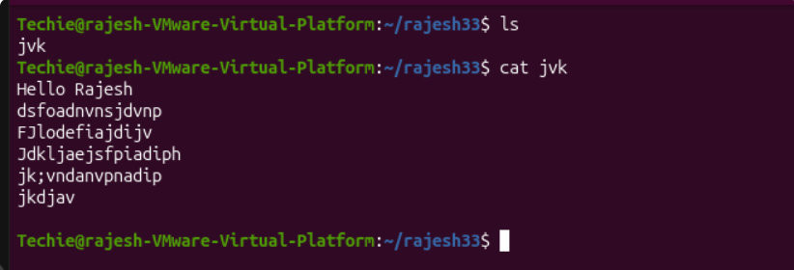
8.Copy a file to another location.
cp <source_file> <destination>
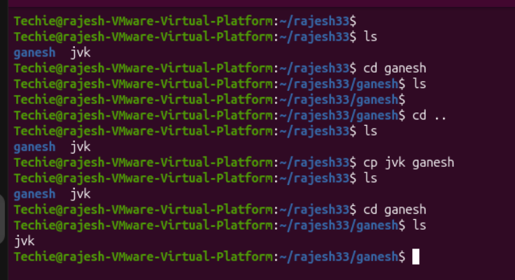
9.Move a file to another location.
mv <source_file> <destination_directory>
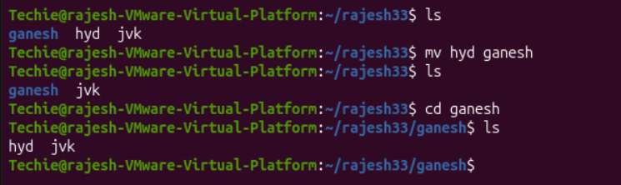
10.Rename a file.
mv <old_file_name> <new_file_name>
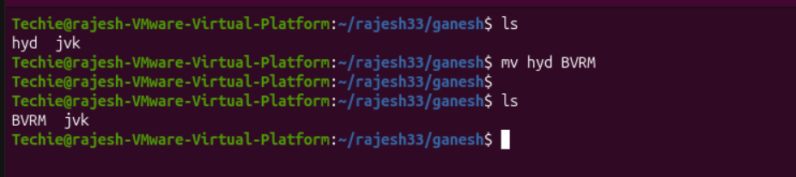
11.Delete a file.
rm <file_name>
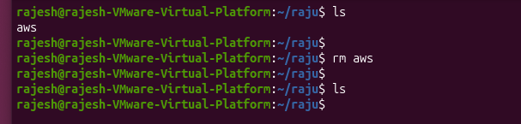
12.Grant or revoke permissions on a file or directory.
Create a filr < touch pwc>
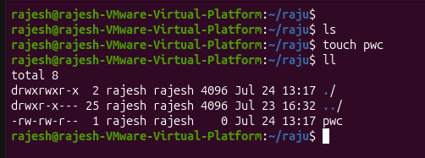
. Grant Permissions
Give Full Permission to Everyon
chmod 777 pwc
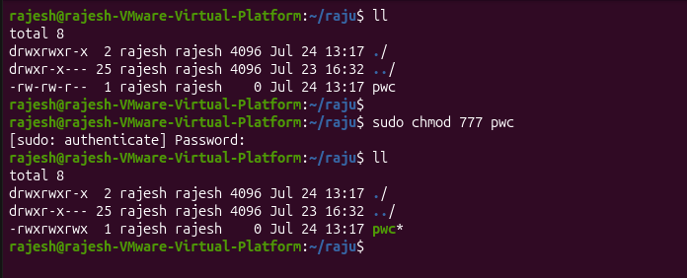
. Revoke Permissions
chmod 644 pwc
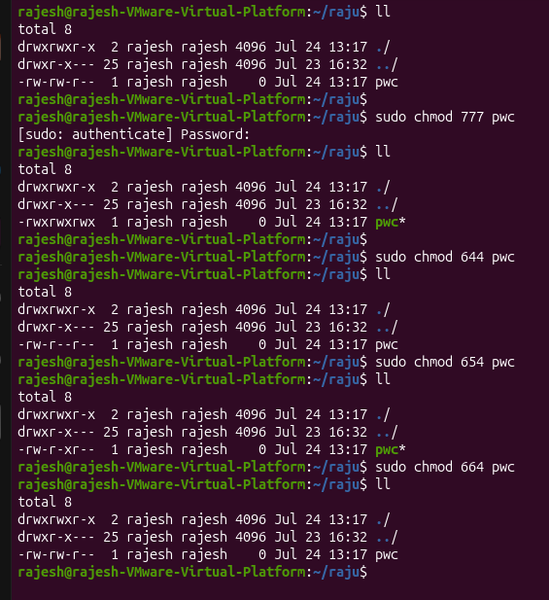
13.View the current date and time.
date
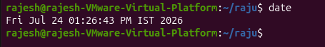
14.Check the system uptime.
uptime
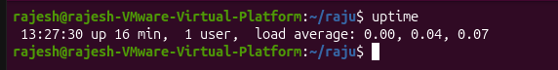
15.View the running processes.
Top
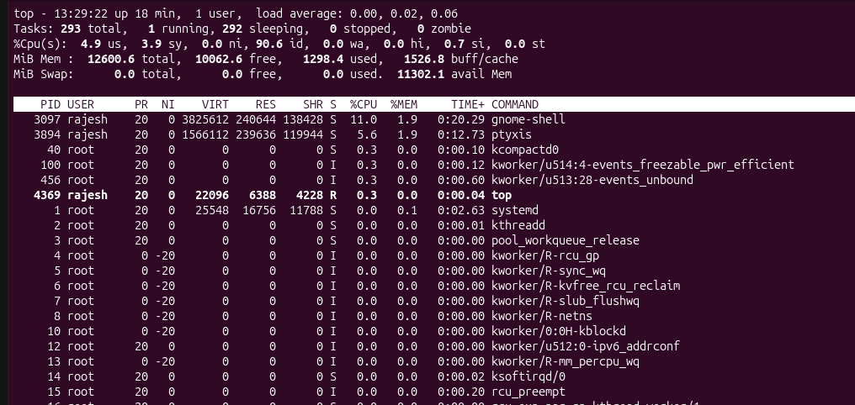
16.Kill a running process.
Find the Nginx Process ID
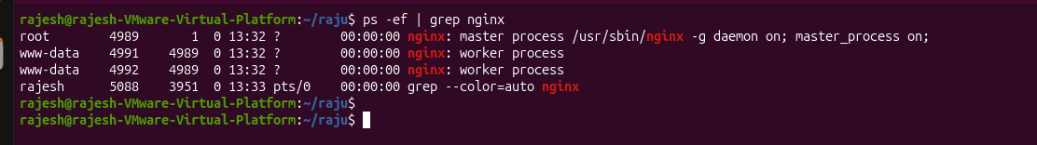
kill 4989
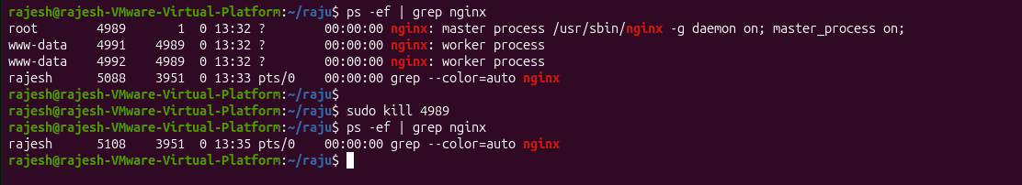
17.Install a package using the package manager (e.g., apt or yum).
Step 1: Update the Package List
sudo apt update
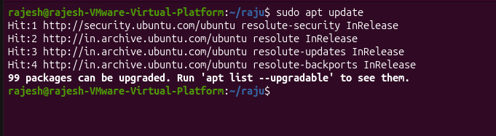
Step 2: Install a Package (Example: Nginx)
sudo apt install nginx -y
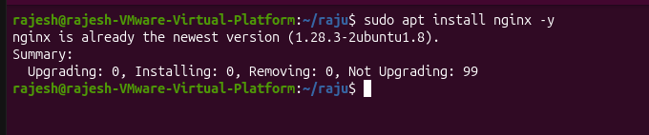
Step 3: Verify Installation
nginx -v
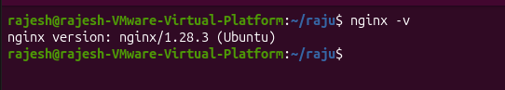
18.Update the system packages.
sudo apt update
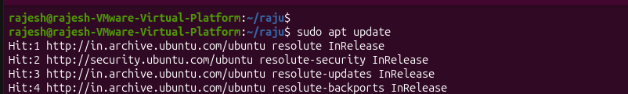
19.Create a symbolic link.
Syntax
ln -s <source_file> <link_name>
- ln → Create a link
- -s → Create a symbolic (soft) link

20.Search for files using the find command.
mv <old_file_name> <new_file_name>
21.Compress and decompress files using tar.
mv <old_file_name> <new_file_name>
22.Monitor system resources with top or htop.
mv <old_file_name> <new_file_name>
23.Create and manage user groups.
mv <old_file_name> <new_file_name>
24.Set up SSH password less authentication.
mv <old_file_name> <new_file_name>
25.Monitor log files using tail or grep.
mv <old_file_name> <new_file_name>
26.Set up a web server (e.g., Apache or Nginx).
mv <old_file_name> <new_file_name>
27.Configure and secure a MySQL Database.
mv <old_file_name> <new_file_name>
28.Set up a Application Server (e.g.,Apache Tomcat)
mv <old_file_name> <new_file_name>
29.create a service file for Apache Tomcat.(Should execute by using systemtctl command)
mv <old_file_name> <new_file_name>
30.Print specific columns from a delimited file.
mv <old_file_name> <new_file_name>
31.Filter and print lines based on a specific pattern or condition.
mv <old_file_name> <new_file_name>
32.Calculate and print the average, sum, or other statistics of a column.
mv <old_file_name> <new_file_name>
33.Perform string manipulation, such as extracting substrings or changing case.
mv <old_file_name> <new_file_name>
34.Count the occurrences of a specific pattern in a file.
mv <old_file_name> <new_file_name>
35.Sort lines based on a specific field or column.
mv <old_file_name> <new_file_name>
36.Merge multiple files based on a common field or column.
mv <old_file_name> <new_file_name>
37.Substitute text in a file using search and replace.
mv <old_file_name> <new_file_name>
38.Delete specific lines based on a pattern or line number.
mv <old_file_name> <new_file_name>
39.Append or insert text before or after a specific pattern or line.
mv <old_file_name> <new_file_name>
40.Print only specific lines from a file.
mv <old_file_name> <new_file_name>
41.Cop file from linux to windows machine
mv <old_file_name> <new_file_name>
42.5 use cases for AWK and 5 use cases for sed
mv <old_file_name> <new_file_name>

